 | RECORDS CERTIFICATION for Public Records
 | 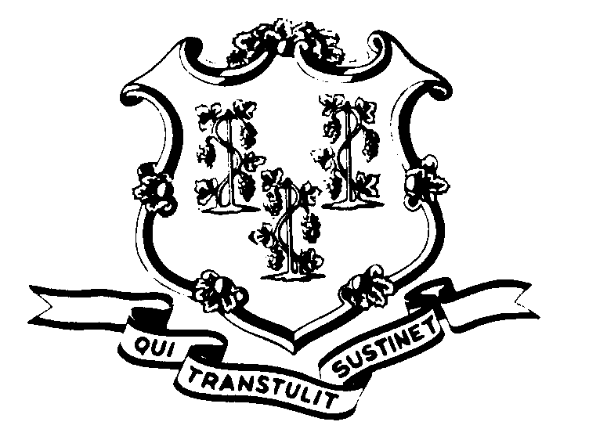  Use this certificate as a target on microfilm to certify authenticity |  | I, the undersigned, do certify that the microfilm images on this reel of microfilm are complete and accurate reproductions of the original records of the below-listed State Agency or Municipality as accumulated during the regular course of business.  It is the established policy and practice of this agency /municipality to microfilm its records for permanent file and to dispose of the original records after microfilm reproductions have been made and assigned to the agency files.  All public records are scheduled and disposed of in accordance with CGS § 7-109, 11-8, 11-8a.
 | Agency / Municipality Name
 | Agency /Municipality Address
Authorized Agency or Municipal Representative

_________________________________ _______________________________________ _______________
Name (type or print) Signature Date

Connecticut State Library
Office of the Public Records Administrator

